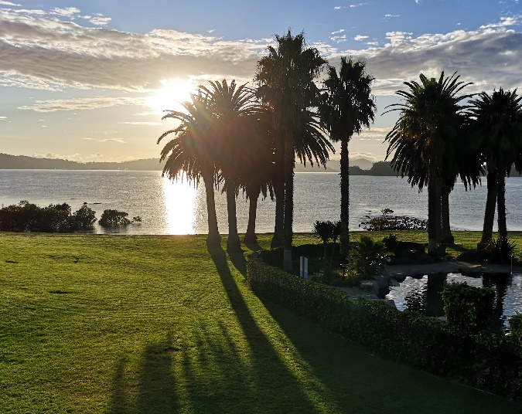

**Biometrics in the**

**Bay of Islands, NZ**

**27 Nov – 1 Dec 2023**

